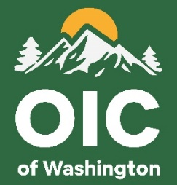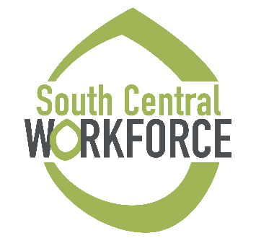

**My Journey Out Beyond**

Monthly Report

Provide a narrative of the activities your team initiated throughout the last month. Can include the following:

* Presentations
* Workshops
* Outings with the youth (WorkSource Tours)
* Outreach to employers
* Collaborations with Partnerships
* Anything notable to highlight the progress of a participant or the program

**Stories of Success**

**STUDENT**

**STUDENT**